**Preparation Home-fun for Hermeneutics Course Level One**

“Theory and Method Underpinned by Values”

Theory: Principles

Method: Tools

Values: Vaiṣṇava Qualities

For participants to get the greatest value from this course, we want to prioritize class time for working on the method of hermeneutics—using hermeneutics to deal with difficult statements and topics.

To do that, participants come to each class with some knowledge of theory. Otherwise, instructors need to spend most of class time on theory, leaving little time for practice.

A theory-laden class might be interesting, and participants might be convinced of the value of hermeneutics, but they would not be very equipped to use hermeneutics in their life and service.

A method-based class is more interesting, more fun, and more useful. Therefore, we ask each participant to prepare for each lesson as follows.

***Before*** each lesson…….

The booklet you are holding in your hand is your **Preparation Home-fun for Hermeneutics Course Level One**. It will help you find what you need to do to prepare for each lesson.

The Śāstric Advisory Council (SAC) has provided five (5) other items to support your study of Hermeneutics.

1. Your ***Participant Handbook*** has your course outline and exploration exercises. The Appendices are in the back of your ***Participant Handbook*.**

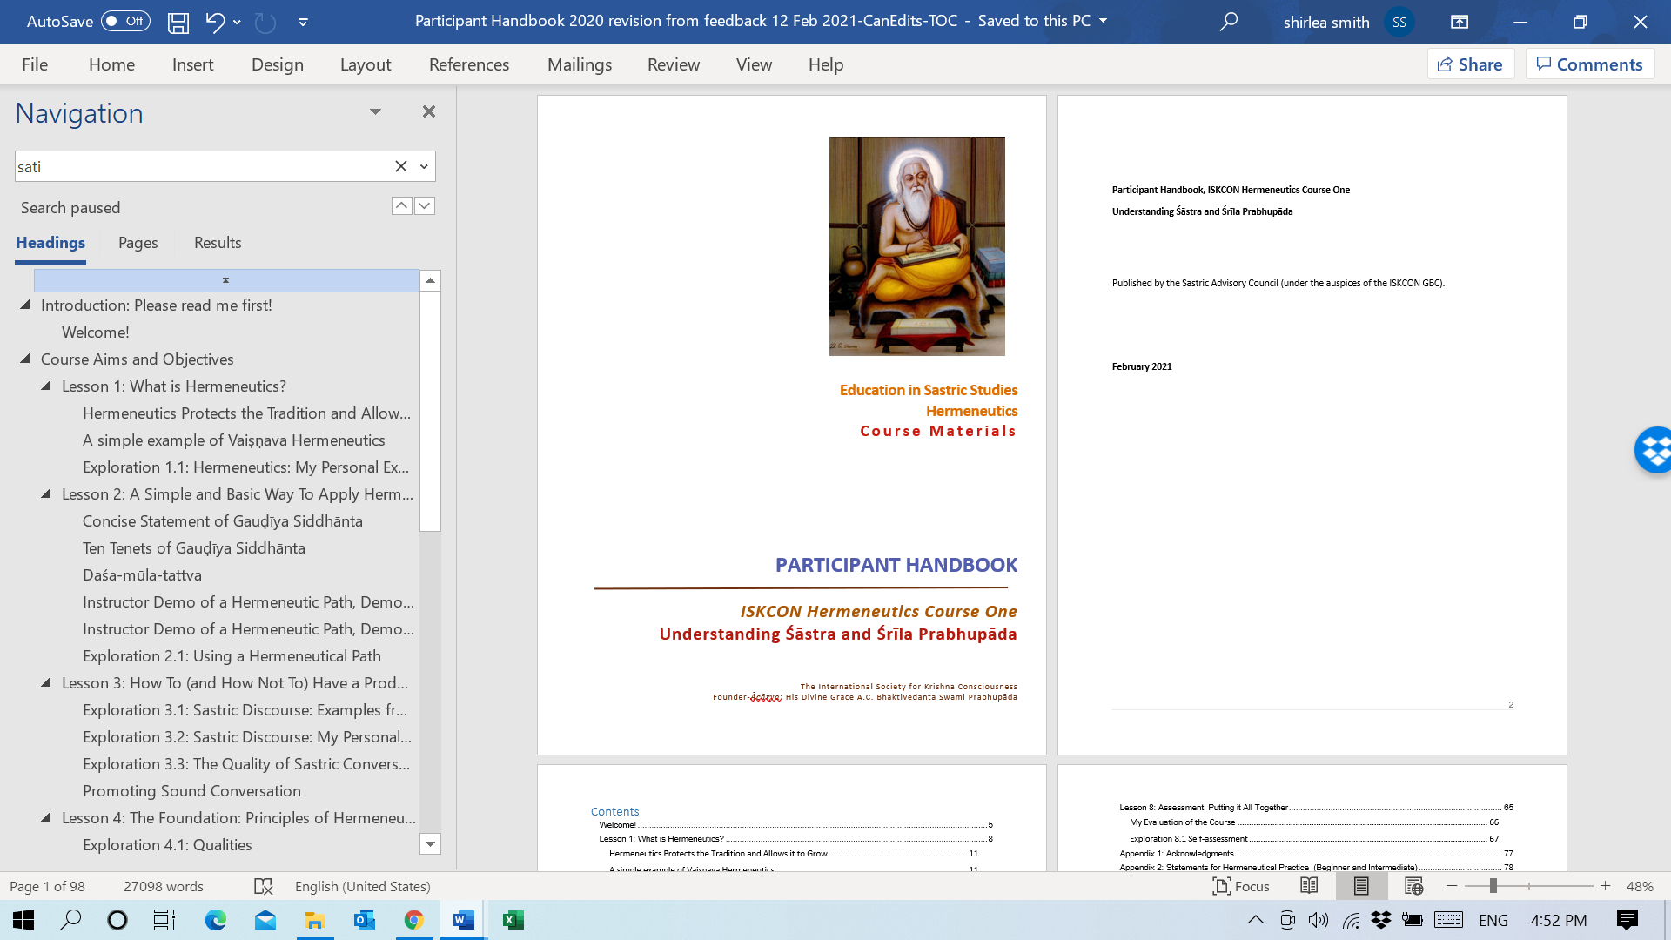

This is the ***Participant Handbook***.

1. The ***Foundation Document*** is a 13-page document containing core concepts.

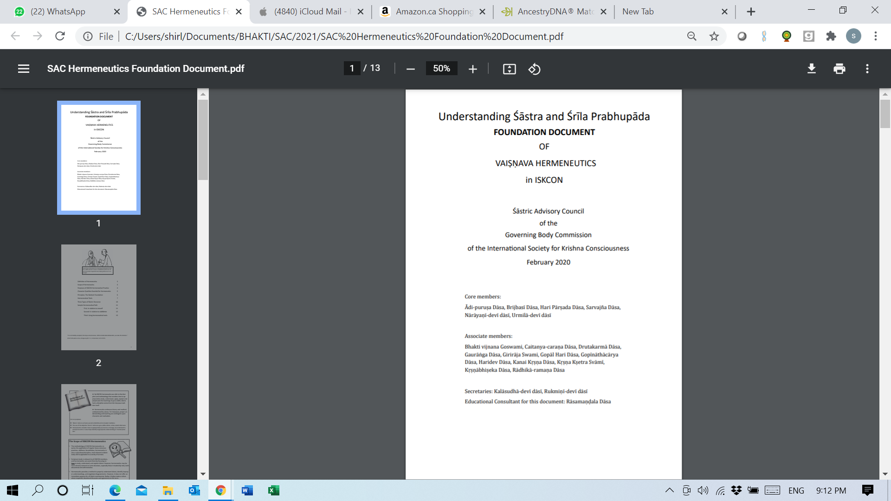

During the course, this 13-page document is referred to as the ***Foundation Document***.

1. You also have a 283 page book, *ISKCON Hermeneutics Supplementary Material*, which unpacks the concepts in detail. It looks like this:

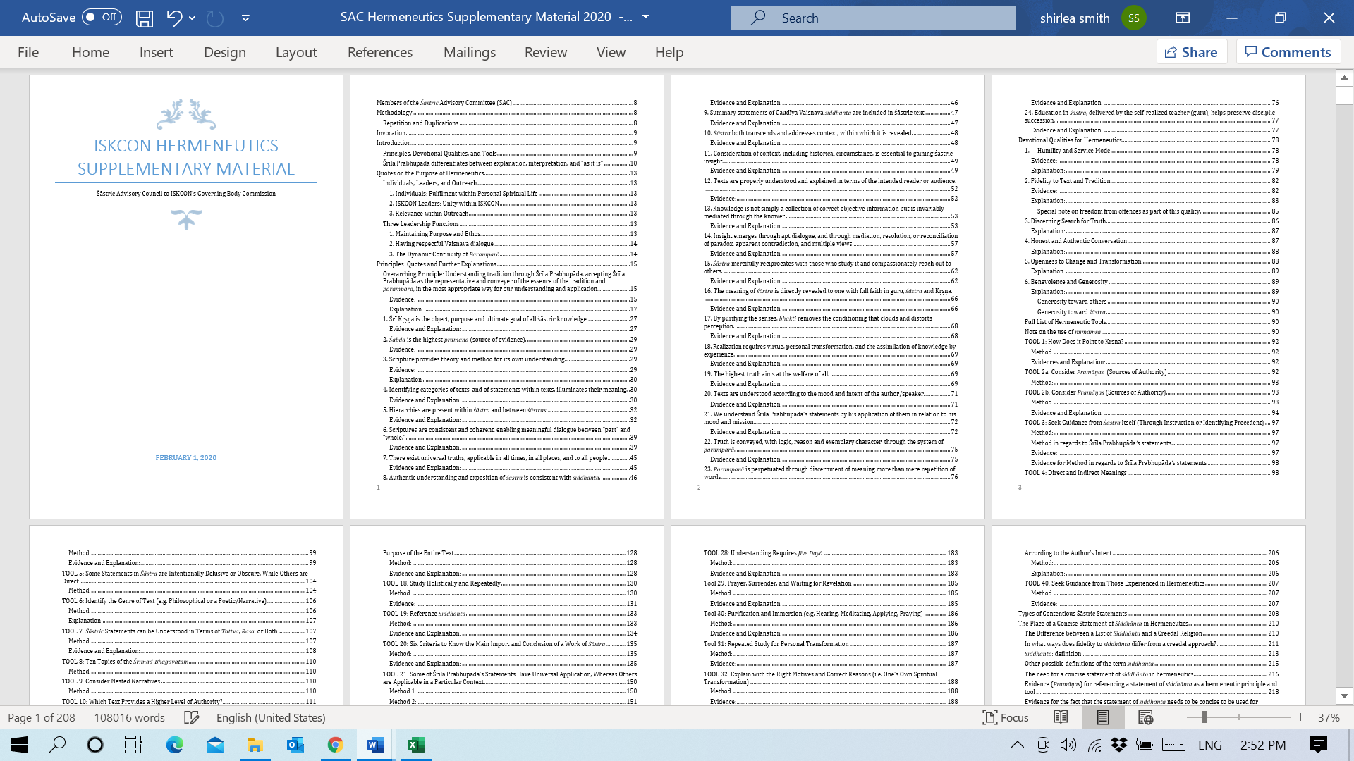

During the course, this 283-page book is referred to as the ***Supplementary* *Material***. You will be reading excerpts from this book as you prepare for your lessons.

1. You have a two-sided document with color graphics. This is your **One-page Summary**.

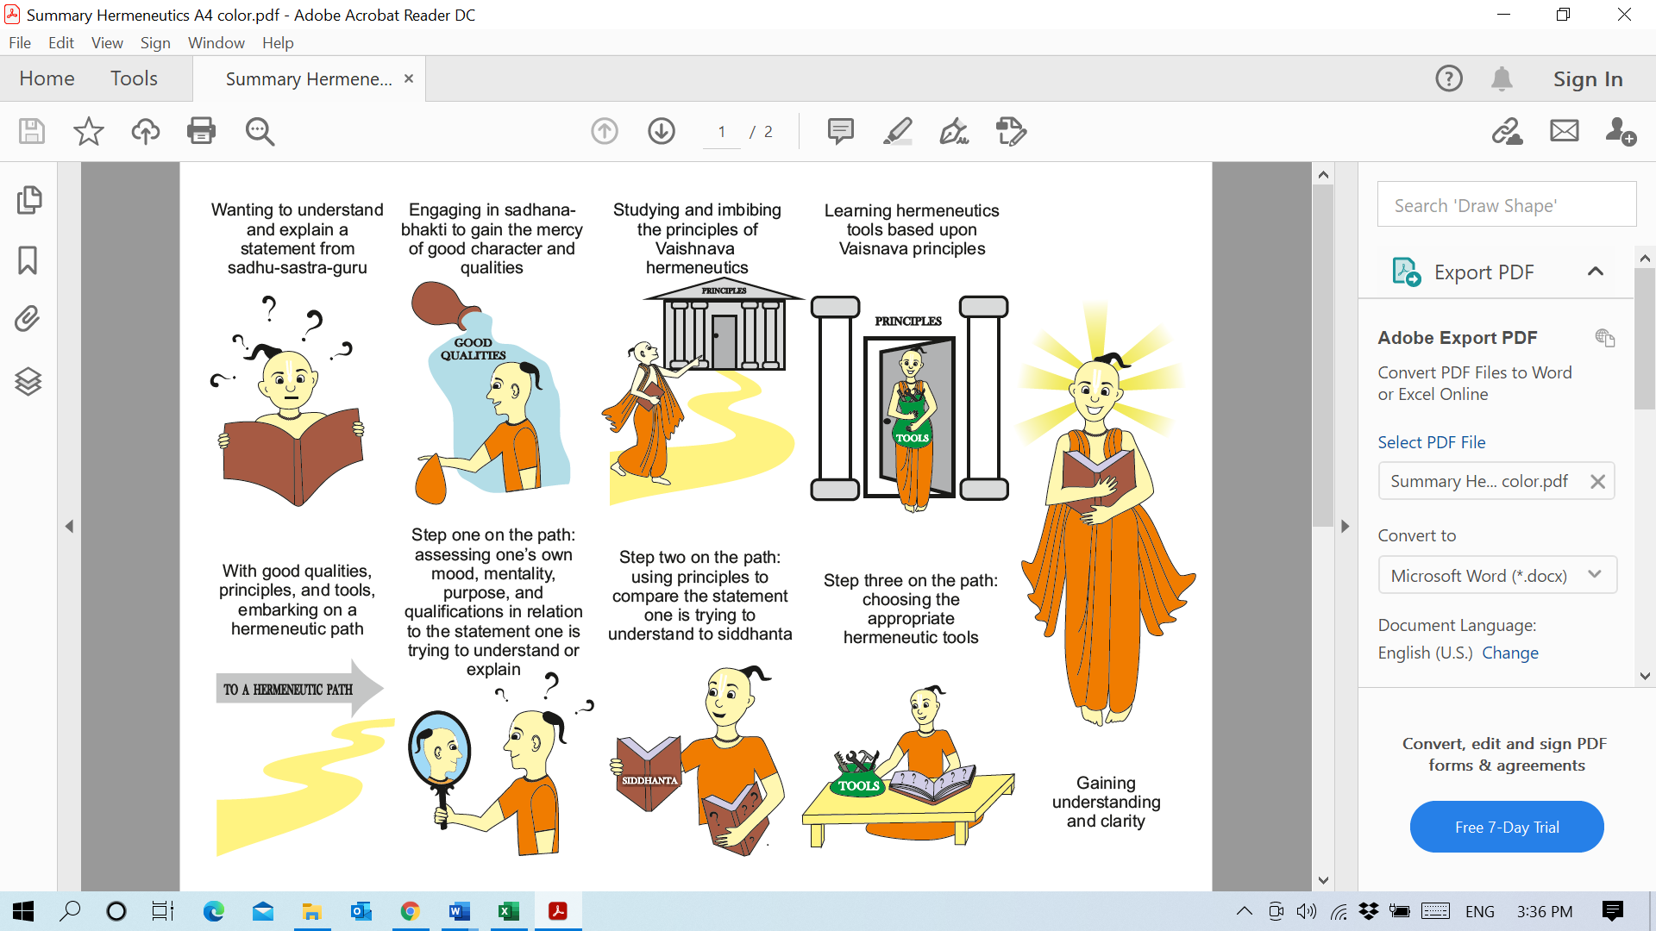

Your One-page Summary will help you review the Hermeneutic Path.

The other side has hermeneutic definitions, purposes, and types of discourses.

1. You have a **bookmark**.

**Lesson 1: What is Hermeneutics?**

**Instructor: ______________________________**

**Date and time: ___________________________**

**Before Lesson 1,** please submit a 3-6 sentence bio to be circulated to all participants before the class starts.

**Before Lesson 1,** carefully read the following:

* *Foundation Document* pages 3 and 4
* *Supplementary Material:* pages 14-18: Śrīla Prabhupāda differentiates between explanation, interpretation, and “As it is”
* *Supplementary Material:* pages 18-20: Quotes on the Purpose of Hermeneutics
* One-page Summary
* *Participant Handbook* Lesson 1

**Before Lesson 1,** please answer as many of the questions on pages 8-9 of your *Participant Handbook* as you can, based on what you read and on your own experience and understanding. Please keep your answers to three lines or less. Answering these will help solidify your basic knowledge as a foundation for the learning experiences in the lesson.

**Lesson 2: A Simple and Basic Way to Apply Hermeneutics**

**Instructor: ______________________________**

**Date and time: ___________________________**

**Before Lesson 2**, carefully read the following:

* *Foundation Document* pages 11-13
* Supplementary Material pages 249-264: The Place of a Concise Statement of Siddhānta in Hermeneutics
* One-page Summary
* *Participant Handbook* Lesson 2, especially
* Concise statement of Gauḍīya *siddhānta* in this *Participant Handbook* page 17
* Daśa-mūla-tattva in this *Participant Handbook* page 18

Essential: Choose one of the following to use for practicing a hermeneutical path:

“Armed with yoga, O Bhārata, stand and fight.” (Bhagavad-gītā 4.42)

OR

“A devotee never takes the part of a particular party; therefore he is carefree.” (Bhagavad-gītā 12.16, purport)

OR

“…these living entities who appear to be our father, mother, etc., are nothing but Kṛṣṇa” (Bhagavad-gītā 9.17 purport)

**Before Lesson 2**, please answer as many of the questions on pages 15-16 of your *Participant Handbook* as you can, based on what you read and on your own experience and understanding. Answering these will help solidify your basic knowledge as a foundation for the learning experiences in the lesson.

**Lesson 3: How To (and How Not To) Have a Productive Discussion: *Vāda, Jalpa, Vitaṇḍā***

**Instructor: ______________________________**

**Date and time: ___________________________**

**Before Lesson 3,** carefully read the following:

* One-page Summary
* Bookmark
* *Foundation Document* page 10
* *Participant Handbook* Lesson 3
* Supplementary Material: pages 214-217, TOOL 27: Type of Discussion or Argument: *Vāda* (Best category is *Samvāda*), *Jalpa*, and *Vitaṇḍā*
* Optional: Appendix 5: Further Questions for Introspection and Discussion page 97

**Before Lesson 3**, please answer the question on page 22 of your *Participant Handbook*, based on what you read and on your own experience and understanding. Answering it will help solidify your basic knowledge as a foundation for the learning experiences in the lesson.

**Lesson 4: The Foundation: Principles of Hermeneutics and Qualities to Apply Them**

**Instructor: ______________________________**

**Date and time: ___________________________**

**Before Lesson 4,** carefully read the following:

* *Foundation Document* pages 5 and 6
* Choose at least three Principles to read more about in the Supplementary Material (Explanation of all 24 Principles pages 21-94)
* Choose at least three Qualities to read more about in the Supplementary Material (Explanation of all 6 Qualities pages 95-108)

Essential: Look over the list of difficult statements in Appendix 2 on page 81 of this *Participant Handbook* and think about what statements you might want to use in the lesson. Choose one specific statement from the following (or your own).

* Statements for Hermeneutical Practice (Beginner/Intermediate) in Appendix 2 on page 81 of this Participant Handbook
* Statements for Hermeneutical Practice (Advanced) in Appendix 3 on page 83 of this Participant Handbook

**Before Lesson 4,** please answer as many of the questions on page 30 of your *Participant Handbook* as you can, based on what you read and on your own experience and understanding. Answering these will help solidify your basic knowledge as a foundation for the learning experiences in the lesson.

**Lesson 5: Putting the Principles and Qualities into Action: Hermeneutic Tools**

**Instructor: ______________________________**

**Date and time: ___________________________**

**Before Lesson 5**, carefully read the following:

* *Foundation Document* pages 7-9
* *Supplementary Material* page 251-253 “In what ways does fidelity to *siddhānta* differ from a creedal approach?”
* *Supplementary Material* pages 204-206 TOOL 24 “*Anubandha*-*catuṣṭaya*: Four Traditional Context Questions”
* *Supplementary Material* pages 236-244 TOOL 37 “Understand a Statement as a Specific Part of an Argument”
* *Participant Handbook* Lesson 5

Essential: Look over the list of difficult statements in Appendix 2 and the list of difficult topics in Appendix 4, and think about what statement or topic you might want to use in the lesson. Choose one statement and one topic in advance of this class.

* Statements for Hermeneutical Practice (Beginner/Intermediate) in Appendix 2 on page 81 of this *Participant Handbook*. (Strongly advise NOT to use the Advanced Statements in Appendix 3 for this exercise.)
* Topics for Hermeneutical Practice (All Levels) in Appendix 4 on page 95 of this *Participant Handbook*

**Before Lesson 5**, please answer as many of the questions on pages 40-41 of your *Participant Handbook* as you can, based on what you read and on your own experience and understanding. Answering these will help solidify your basic knowledge as a foundation for the learning experiences in the lesson.

**Lesson 6: Doubts and Uncertainty Among Devotees**

**Instructor: ______________________________**

**Date and time: ___________________________**

**Before Lesson 6**, carefully read the following:

* *Participant Handbook* Lesson 6
* Supplementary Material pages 68-73: Principle 14, “Insight emerges through apt dialogue, and through mediation, resolution, or reconciliation of paradox, apparent contradiction, and multiple views.”

Essential: Look over the list of difficult statements in Appendix 2 and Appendix 3, and think about what statements you might want to use in the lesson. Choose one statement in advance of this class.

* Statements for Hermeneutical Practice (Beginner/Intermediate) in Appendix 2 on page 81
* Statements for Hermeneutical Practice (Advanced) in Appendix 3 on page 83

**Before Lesson 6**, please answer as many of the questions on page 50 of your *Participant Handbook* as you can, based on what you read and on your own experience and understanding. Answering these will help solidify your basic knowledge as a foundation for the learning experiences in the lesson.

**Lesson 7: Beyond the Devotee Community--Outreach on Difficult Points**

**Instructor: ______________________________**

**Date and time: ___________________________**

**Before Lesson 7**, carefully read the following:

* *Participant Handbook* Lesson 7
* The three Explorations (just read them. We will do them during the class.)

**Essential:** Look over the list of difficult **statements** in Appendix 2 (page 81) and the list of difficult **topics** in Appendix 4 (page 95), and think about what statements you might want to use in the lesson. You might want to choose **two** specific ones in advance

* Statements for Hermeneutical Practice (Beginner/Intermediate) in Appendix 2 (page 81)
* Topics for Hermeneutical Practice (All Levels) in Appendix 4 (page 95)

**Before Lesson 7**, please answer as many of the questions on page 58 of your *Participant Handbook* as you can, based on what you read and on your own experience and understanding. Answering these will help solidify your basic knowledge as a foundation for the learning experiences in the lesson.

**Lesson 8: Assessment: Putting it All Together**

**Instructor: ______________________________**

**Date and time: ___________________________**

**Before Lesson 8:** If your class for Lesson 8 is directly after Lesson 7, carefully read over this lesson before the class.

**OR**

If you have a half-day or more between Lesson 7 and Lesson 8, complete **all** of the Lesson 8 self-assessment before the class. For question #1 complete **all** three sections A, B, and C.