Jagannath Month Week 4

Prabhupad’s Ratha Yatra
Week 1- Jai Jagannath
Week 2- Ratha Yatra
Week 3- Cleaning Gundicha Temple
Week 4- Ulta Rath- Make your own Rath festival
For those of you who love the idea of a small family festival, but feel nervous about adding anything to your already-full life right now, I have some tips for how to organize a festival with a handful of families and make it a memorable experience for everyone (kids and parents!) with minimum stress. As I write this, I am coming back from a Ratha Yatra festival that I put together with one other friend, and it was an amazing experience and I felt like I had hardly done any work. Please look at the “Field trip or Festival” part of the document to see my suggestions. You need this. Parenting is tough and the pressure of bringing your kids up Krishna Conscious can make it tougher. A fun kid-friendly festival is a great way to inspire you, the parent, that yes! Krishna Consciousness can be easy and fun for kids! And if that isn’t enough to convince you, just watch Urmila Mataji’s Youtube video of the 4 components of raising your children to become devotees. Good watch anyway, even if you are already convinced ;-)

https://www.youtube.com/watch?v=pEkPYFYiuyI

A Story about Krishna’s pastimes
This week I thought the kids would enjoy to hear the story of Srila Prabhupad’s first Ratha Yatra, which, if you didn’t know already, he organized when he was about 5 years old.
When Srila Prabhupada was five years old, he heard about the huge Ratha Yatra festival held annually in Jagannatha Puri, and wanted to make his own Ratha Yatra festival. At that time in Kolkata, people commonly made small Ratha Yatra festivals in their families, communities and temples, and so one day when little Abhay was walking home with his father, he noticed a beautiful small Rath cart outside a carpenter’s workshop. (This story is from memory- perhaps his father asked the carpenter how much it would cost to make one- I don’t remember) His father, Gaur Mohan De, inquired about the price, but sadly, they didn’t have enough money for it. Little Abhay began crying loudly and continued crying all the way home, which attracted the attention of a passing elderly Bengali women who kindly let him buy her old Rath cart for a price they could afford. Srila Prabhupada enlisted the help of the neighbourhood children and their mothers in an elaborate eight-day spiritual festival that he continued annually during his boyhood. This same festival would eventually be established by Srila Prabhupada on five continents.
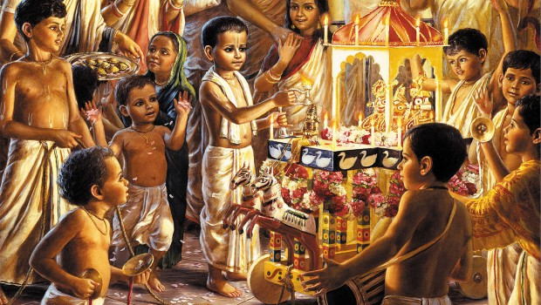

A fiction story about devotee children
One day Mommy told Akshay the story of how Srila Prabhupad made his own Ratha Yatra celebration with his family and friends when he was only five years old. Akshay was eight already, so he asked his mom, “Could I organize a Ratha Yatra festival for my Jagannath as well? I am sure They would love that!”
There were so many things to organize:
- Finding or making a Rath Cart
- Figuring out where and when to have the festival
- Inviting guests
- Planning a potluck menu- Akshay and Sharanam would make mango popsicles
- Getting paper plates and cups
- Getting a broom and decorating it
- Organizing and setting up an aroti tray
- Finding a Harmonium, Mridanga and Karatalas.
- Decorating the cart
- Figuring out how to bring the deities and make sure they don’t fall during the procession
Akshay sprang out of bed on Sunday. It was the day of the Rath Festival! He checked on the mango popsicles in the freezer- frozen! He got showered, brushed his teeth, and dressed so he could get started on the other preparations. He woke up Lord Jagannath, Who seemed to be smiling extra big that day and lovingly wiped Their bodies with a wet cloth that was especially for Them. He wanted to put them straight in the box to be ready to take them to Their Ratha Yatra, but his mom told him to leave them on the altar till it was time to go. So after breakfast, he went to his friend’s house and together they cleaned up the cart with wet cloths, tied garlands on the cart, made a flag to go on top, and even got to put some fresh paint on the parts that were peeling off.
“Oh no!” Akshay’s mom said as she was making a quick pasta lunch. “I forgot to buy a new broom to sweep the road on Ratha Yatra!” What to do? They needed an outside broom that could work on the road and all they had in the house were the soft inside brooms. Akshay had a great idea. He figured out how to make his own broom out of dried palm leaves! He just broke the leaves off of the stem, and wrapped them with string and it made a really fun broom that was a perfect size for kids. He made three brooms so his friends could get a turn as well.
Finally, after lunch he got to take his Lord Jagannath, Baladev and Subhadra in Their box to the Samadhi for the festival. But oops! They almost forgot! Akshay’s father had to fix one of the wheels on the cart! They got the tools together as quickly as possible and rushed over to his friend’s house to fix it back on. The wheel had fallen off the previous year and was still detached from the cart. Good thing Akshay’s dad knows how to fix pretty much everything.
They rushed from the house to the Samadhi, Akshay carrying the deities, Mom holding Baby Shyam, Sharanam holding the garlands, and Akshay’s Papa carrying the whole cart. Akshay used blutack under the deities so they wouldn’t wobble, and there was an extra rope at the back of the cart to make sure it didn’t go too fast. Baby Shyam loved holding that rope!
Akshay never wanted to forget this moment. The light rain made cooling breezes that wafted through the curtain of flower garlands that decorated the cart to refresh Lord Jagannath with their fragrance. Kids got to pick red and pink flowers on the sides of the road to offer to Lord Jagannath. Visitors who came to Mayapur respectfully asked for turns to sweep the road for the Lord and gently pull the cart, and then one of them placed a rupee coin on the cart! After that, the visitors kept giving more and more ten rupee notes in front of Lord Jagannath. Akshay never expected that.
And then the wheel fell off! Luckily for the blutack, Lord Jagannath didn’t fall off of the cart, but everyone was pretty worried. Akshay’s mom reminded everyone that even though Lord Jagannath gives us the opportunity to serve Him by pulling His cart, if He doesn’t want to move, the cart doesn’t go. Coincidentally Akshay’s dad had brought the wrench in his shoulder bag, so he got to work on fixing the nuts and bolts to screw the wheel back on and they were ready to go again.
Later when they were getting the aroti ready after the procession, Akshay’s father told everyone about how Lord Jagannath’s rath cart stopped one day in the grand procession of Puri.
Bhaktivinode Thakur used to live as a magistrate in Puri in Orissa. His house was right on Grand Road in Puri where the huge Ratha Yatra procession goes. While he was living there he would regularly go to the Jagannath Temple and pray to Lord Jagannath asking for a son to further the movement of Lord Chaitanya. After a while, his wife had a beautiful and healthy son who he named Bimala Prasad- or the faultless mercy of the Lord. One day when Bimala Prasad was about five months old, the annual Ratha Yatra was going past their house, with baby Bimala Prasad kept inside away from the crowds. Just as Lord Jagannath’s cart was going past their house, the cart stopped and wouldn’t move for anything. People pushed and pulled with all their might, and the cart was checked for any malfunctioning, but no one could understand why it wouldn’t move. Then Bhaktivinode Thakur decided that he should bring little Bimala Prasad outside to see Lord Jagannath, as indeed he was the gift from Lord Jagannath. As he stood holding the baby in front of the cart, Lord Jagannath’s garlad fell off, right onto baby Bimala Prasad! As soon as that happened, the transcendental brakes on the cart lifted, and Lord Jagannath’s chariot could move again. That baby grew up to become Bhaktisiddhanta Sarasvati Thakur.
“Lord Jagannath really is magical.” Akshay thought. It seemed like the whole festival came together by the sweet will of Lord Jagannath- the soft rain, the people, the prasadam, everything went smoothly (apart from the wheel) by Lord Jagannath’s desire.
After they got home, they put Lord Jagannath on His altar, but they were not satisfied and wanted to serve Him more. So they got out His other outfit, and set about starting to make a new outfit for Them with the pearls and silk his mom had saved. Serving the Lord was so much fun!

Song related to the Stories
Sorry nothing new this week- just the same ones from last week:
This great song was composed in the 80s by Bhavatarini in Los Angeles. She also made a coloring book and a CD with many more songs. I am trying to get a link where you can buy the whole CD.

Cleaning Gundicha temple
Lord Jagannath and Subhadra
And Lord Balarama
Soon will appear on chariots drawn
To the Gundicha Mandir
Hundreds of water pots, hundreds of men
Await for the signal to begin
To cleanse the temple is Chaitanya’s will
This His devotees wait to fulfil
Cleaning began, chanting all the while
Competing to make the biggest dirt pile
Gathering dirt and dust straw dung
Of course Lord Mahaprabhu won.
Chaitanya praised if one’s work did excell
Chastised when needed, with love as well.
Everything asked for using the Holy Name
The reply would be the same.

Some brought the water
Some swept with brooms
Washing and polishing all the rooms
Some fetched from the lake, some from the well
Sometimes colliding pots broke and fell.
Chaitanya cleansed Jagannath’s sitting place
With His own clothes to wipe every trace.
So bright and clean, it did appear
Like Chaitanya’s mind so pure and clear.

Lord Hari chanting blissfully
Washing the temple in ecstasy
Lord Hari chanting blissfully
Washing with tears of ecstasy
By His example we can tell
One who cleans the temple, cleans the heart as well.
By His example we can tell
This mahamantra cleans the heart so well.

Then they let the water free
Flowing like rivers to the sea
The temple clean now shone brightly
Like the hearts of the pure devotees
Lord Hari began to roar
Krishna’s Holy Names loudly
With the other devotees
Hare Krishna Hare Rama
They did all begin to cry
The sound vibrated in the sky
Dancing like a maddened lion
In this state Gaur Hari
Shook the earth with ecstasy
Shook the earth with ecstasy
Shook the earth with ecstasy
Shook the earth with ecstas

Bengali Song
I have another rhyme in Bengali for those of you who would like to learn:
Ek Dui Tin. (one, two, three)
Shubho Jonmo din (happy birthday)
Chaar Panch Choy, (four, five, six)
Khabo Mishti Doy (I will eat Mishti Doy)
Shaat, Aat, Noy, (seven, eight, nine)
Nitai Doyamoy, (Nitai is most merciful)
Sheshe kohe Dosh (at the end, we say Ten)
Thanda lebu rosh! (cold lemonade!)

Bhajans for Parents to learn and sing and listen to.

This song is very very beautiful and glorifies how Lord Chaitanya is the same as Lord Jagannath and Krishna Himself. The melody is on the webpage here: http://kksongs.org/vsongs/jayajayajagannatha.html

(1)
jaya jaya jagannātha sacīra nandan
tribhūvana kore jār caraṇa vandan

(2)
nilācale sańkha-cakra-gadā-padma-dhar
nadīyā nagare daṇḍa-kamaṇḍalu-kar

(3)
keho bole purabete rāvaṇa badhilā
goloker vaibhava lilā prakāśa korilā

(4)
śri-rādhār bhāve ebe gorā avatār
hare kṛṣṇa nām gaura korilā pracār

(5)
vāsudeva ghoṣa bole kori joḍa hāt
jei gaura sei kṛṣṇa sei jagannāth

TRANSLATION
1) All glories, all glories to the dear son of Jagannatha Misra and Saci Devi! All the three worlds offer prayers unto His lotus feet.

2) In Nilacala He holds the conch shell, disc, club, and lotus flower, while in the town of Nadiya He holds a sannyasi staff and water pot.

3) It is said that in olden times, as Lord Ramacandra, He killed the demon Ravana. Then later, as Lord Krsna, He revealed the splendrously opulent pastimes of Goloka.

4) It is He who has come. He has come! Oh, from Vraja He has come to Nadiya. Accepting the mood and luster of Sri Radha, He has come from Vraja to Nadiya. He has come! Now Lord Govinda, the cowherd boy, has come as Lord Gauranga. He has come distributing the Hare Krsna Mahamantra!

5) Vasudeva Ghosa says with folded hands, “He who is Gaura is He who is Krishna is He who is Jagannatha.”

Suggestions for Nature Altar
- Would be great to print out a picture of Prabhupad on Ratha Yatra-
- So to tell the fiction story, I made some “handkerchief dolls” with some dried up forgotten limes for the heads, scraps of cloth, and rubber bands. Here are my props:
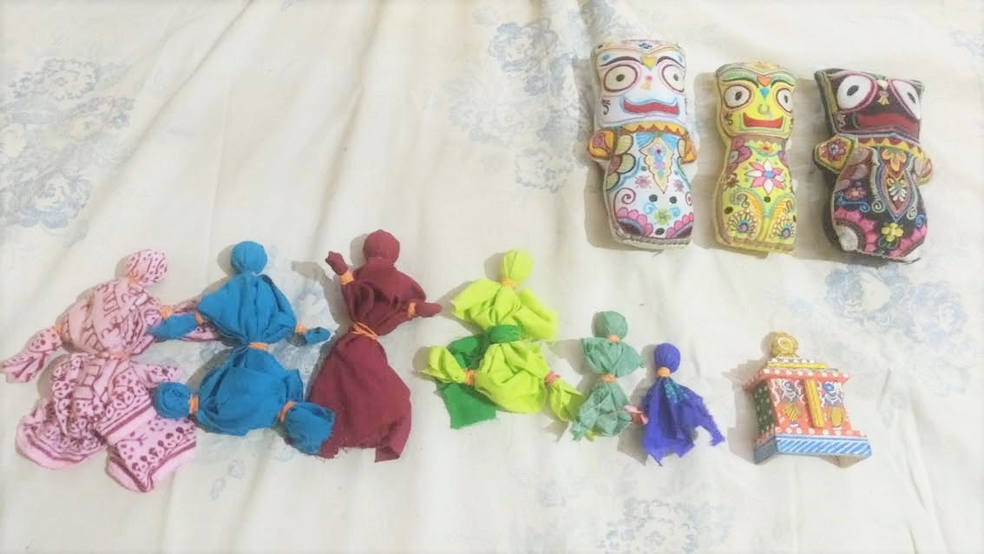
- From left to right, the characters are Pujari Mataji, Grandpa, Mama, Akshay, Sharanam, Baby Shyam, and the present that Akshay got. The big dolls are the deities that Grandpa worships.

An Activity related to the story or festival
Make your own Rath Cart- some ideas are:
Decorate a kids’ wagon or even a stroller for Jagannath Dolls
Perhaps this youtube tutorial could be adapted for a small rath cart: https://www.youtube.com/watch?v=ZVSfccgKlXA
Here is a photo of a kids rath cart made from a small table for any of you who might be or know some handy men:
https://in.pinterest.com/pin/473018767083343989/
There is a very old book published by Mandala with a make your own Rath Cart using a milk carton and cardboard wheels. I think this might be it: http://www.simonandschuster.com/books/Jagannatha/Mandala-Publishing/9780945475293

A Field Trip or festival
Make your own Ratha Yatra festival! Believe me, the hard part is getting a cart together, once you have that, the rest of it can be really easy! Here are my suggestions for a successful stress-free festival:
- Keep it Simple
With kids, usually less is more. For them, something simple like hearing a story, or getting to bathe the deities themselves is a memorable experience. Our plan for the Ratha Yatra festival was as follows:
- Pull Lord Jagannath on His Rath cart
- Listen to a story
- Have Kirtan, Aroti and Bhog offering
- Eat Prasad together
- Free play in the park
After Prasad, kids were a bit tired of organized activity and were much happier just playing around with friends. Do you notice the rhythm of Breathing In and Breathing Out in our plan?
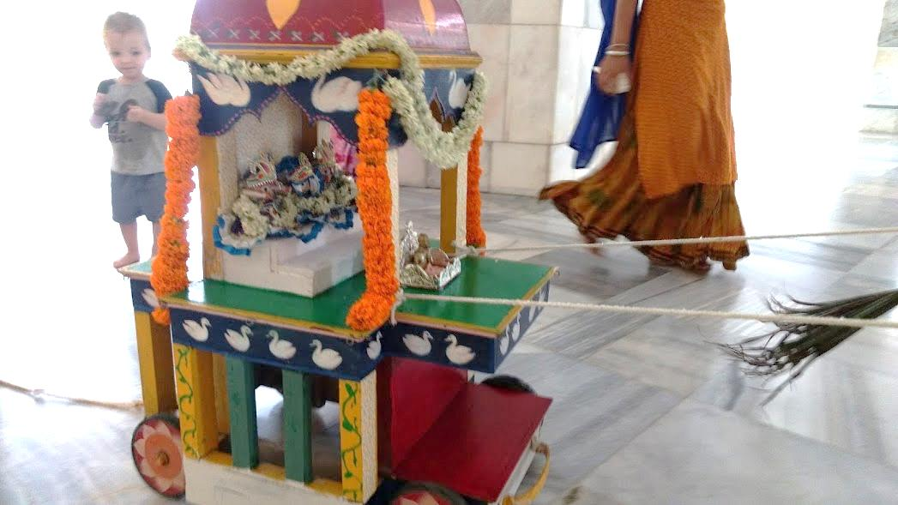
- Decide on a stress-free venue
There are some of you I’m sure who are domestic goddesses and have pretty clean houses all the time, even when planning and cooking for a party, but for the rest of us, planning a party in a public place like a park or the temple, eliminates the “clean house” item off of the party to-do list. It also tends to make parking, directions and clean up easier for everyone else, and keeps the festival a bit more focused. I like to organize kids festivals on off days from the “real” festival, so that it doesn’t conflict any one’s schedule, and so that the temple room is free if we want to use it.

We are lucky to be in Mayapur, where we got to take Lord Jagannath around the road outside Prabhupad’s Samadhi, but I think a local park would have been great too. The pilgrims visiting Mayapur thought it was just incredible and I think they got a very nice impression of our community. After we pulled Lord Jagannath, we had kirtan in the park of the Samadhi and the kids got to play around in the grass.
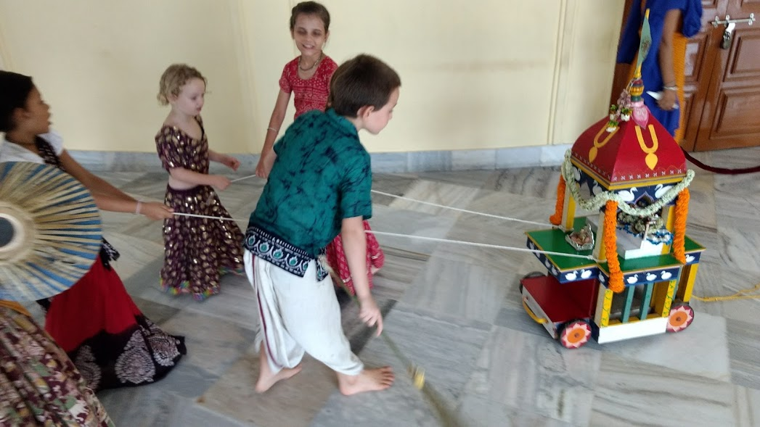

- Invite friends who are willing to contribute and be clear on expectations
I have a friend who used to host amazing Janmasthami festivals for kids and her formula was to assign a menu item and an activity preparation for each mum involved. So in the end with 6 mums, there would be about 15 kids, 6 activities, and a 6 item feast. All she had to do was one item and activity, give people ideas and plan the time and place.

Those Janmasthami festivals were more elaborate than our Ratha Yatra, so all we asked was for each family to bring one offering for the Lord. In the end, we had about 8 participating families and 20 children, and some parents came last minute without an offering but there were still plenty of sweets to go around ;-) My friend and I got together a few days before to plan everything else:

My to-do list:
- Find Rath Cart
- Bring Deities
- Invite friends
- Bring “the king’s broom”
My friend’s to-do list:
- Prepare Arti tray- We just offered incense and flowers!
- Decorate and clean the cart
- Bring Srila Prabhupad and blutack so the deities wouldn’t fall
- Bring instruments
We probably could have delegated some of our tasks to other guests who came, but we weren’t too busy last week so it wasn’t too bad.
- Plan with the kids in mind
Timing can be really important. In Mayapur every year some families usually organize a family friendly Damodar program every kartik as the evening program in the temple is too late for lots of kids who have to get up early for every morning. I have noticed that early afternoon is usually a great time for kids festivals if the weather is good at that time. Late morning might work for you as well. You also want to make sure there is access to shade, faucets and bathrooms at your venue.

Another thing that makes the festival so much more memorable for children is if they are involved in the planning and preparation of it as well as the cleanup. Usually kids are so excited about a festival, they are jumping for the chance to cooperate and help out in tasks that they might otherwise complain and cry about. I know that kids’ help usually means that the task will take longer and could mean more work for you, but as much as you can, this part is what makes the festival really meaningful to them, and eventually they will be organizing festivals for you.
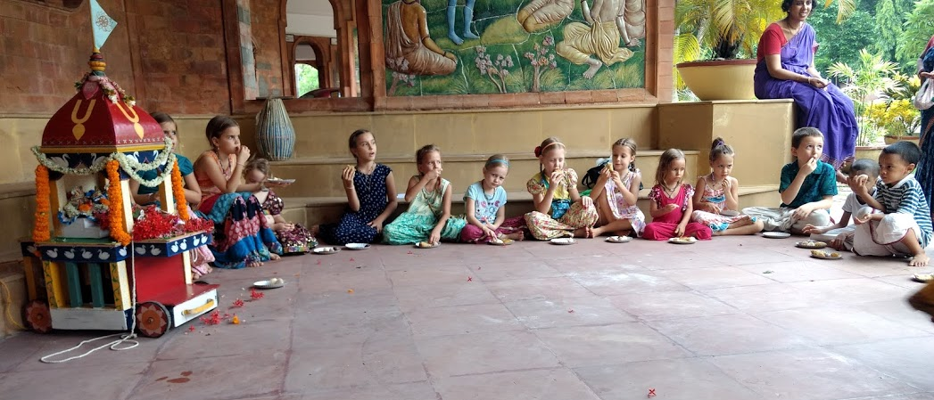

- Try to do as much as you can the day or week before.
The anticipation for a festival can be pretty strong for kids, and they will get more excited about it if they are making preparations for days ahead. This also helps them to relish the waiting part of life- if they have something to do while they are anticipating something exciting.

I always prefer to make a preparation the day before, as there is always more than enough to do on the day of the festival. This way you can also involve your kids without too much anxiety about the time you all take making it. If you are cooking something that has to be fresh, you can prepare all the ingredients in one place so that when you are about to make it, you are completely prepared to let your kids help you as well. They can help you with arranging the ingredients as well, like peeling and cutting veggies, or measuring out grains or flour.

Recipes for this week
I used little tiny 100 mL cups for these popsicles to make them easy to serve out at a party.
Mango ice cream recipe:
I am writing this recipe from memory, so please forgive me if the sweetness level is a little off. Of course if it is made with love, Krishna will accept it anyway, and if it frozen, your kids will enjoy it anyway. And who needs a bunch of kids on a mega sugar high right?
First, peel 6 kilos of mangoes. If you don’t live in the tropics like us, perhaps you could try the same recipe with 10 lb of Strawberries? I think strawberries might require more condensed milk as they aren’t as sweet as mangoes. The real fun part is squeezing the mango flesh off of the seed. If you are using strawberries, you could mash them with a potato masher instead of blending them for chunky ice cream.
Then you add:
400 ml heavy cream (or 16 oz) in India this is two small cartons of “Amul Fresh Cream”
800 ml condensed milk (about 30 oz) probably more for strawberries
Proceed to blend whichever way works best for you. Little kids love stick blenders, and they are good at adding air to the mixture so that the ice cream comes out fluffier, but a jug-blender works in batches as well. Once you have everything blended, just pour it into small paper cups, put popsicle sticks on the top, and freeze.

Teacher and Kids’ Handwork ideas
Make Your Own Broom- There are so many cool things to do this week! While making or decorating a Rath Cart will take plenty of your time, making your own “king’s broom” like Akshay does in the story is really fun too. If you are not in the tropics, perhaps you can use tall grass or straw instead of palm leaves. Alternatively, you can simple decorate a normal broom and cut the handle shorter to make it kids’ size.
Make outfits- If you are a sewer this is a great time to make outfits for the Lords.
As always, I am very happy to receive suggestions, corrections and any improvements at all for this work.
Jai Jagannath!

