Jagannath Month Week 2

Gundicha Marjan
Week 1- Jai Jagannath
Week 2- Ratha Yatra
Week 3- Cleaning Gundicha Temple
Week 4- Ulta Rath- Make your own Rath festival

A Story about Krishna’s pastimes

The song lyrics included later in this document retell the story of Gundicha Marjan in detail.
Below is a link to a class given by Srila Bhaktisiddhanta Sarasvati Thakur. It’s a little heavy and definitely for adults, but you can read the story in here as well and adapt it for kids.
http://www.gaudiyadarshan.com/posts/sri-gundicha-marjan-lila-rahasya/

Here is the main content of the Gundicha Marjana pastime exerpted from the website link:

Śrī Gaurasundar first swept out large heaps of all such sand, straw, dust, and so on, that had accumulated over many days and then, after cleaning every area within the Temple a second time with brooms and water, began scrubbing the Temple and the Lord’s altar with the dry cloth He was wearing so that no subtle blemishes would remain anywhere.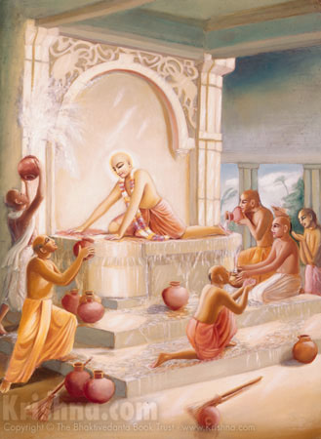
After all of the sweeping, cleaning, scrubbing, and so on, there was no trace of any dust particles or even subtle blemishes within the Temple, which was not not only spotlessly clean but also soothingly cool, that is, the practitioner’s heart had become free from the bearing pain comparable to being a desert scorched by the sun—free from the flames of the fire of the three miseries produced by desire to enjoy the mundane (ādhyātmik-tāp: miseries caused by the body and mind; adhibhautik-tāp: miseries caused by others; and adhidaivik-tāp: miseries caused by the gods). In fact, when desires for enjoyment and liberation—all extraneous desires, worldly endeavours, speculative knowledge, yoga, and so on—are dispelled from the practitioner’s heart and the soul’s propensity for pure devotion manifests, such peace and soothing coolness appear naturally.
Ignorant souls do not understand that often, even when all selfish desires have been dispelled, a subtle blemish still remains within an unknown nook or corner of the heart: the desire for liberation. What to speak of the impersonalists’ desire for sāyujya-mukti (the liberation of merging into Brahma), Śrīman Mahāprabhu scrubbed away with His own cloth even the subtle blemishes of desire for the four other forms of liberation [sālokya: residing in the Lord’s abode, sāmīpya: being in the Lord’s presence, sārūpya: having a form like the Lord’s, and sārṣṭi: having opulence like the Lord’s].
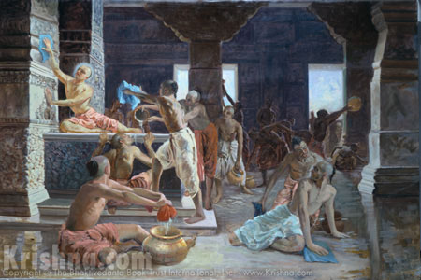
In this way, adopting the mentality of an soul for the welfare of all souls, Śrī Gaurasundar, as a Jagad-guru, personally taught how a practitioner should, with great enthusiasm, while loudly chanting Kṛṣṇa’s Name, clean their heart for Kṛṣṇa’s sake in order to make their heart a place for the pleasure Pastimes of the Autocrat Śrī Kṛṣṇa and be able to lovingly gratify Kṛṣṇa’s senses.
yadyapyanyā bhaktiḥ kalau kartavyā,
tadā kīrtanākhya-bhakti-saṁyogenaiva
(Krama-sandarbha-ṭīkā on Śrīmad Bhāgavatam 7.5.23–24)
[“Although the other eight practices of devotion should be performed during Kali-yuga, they should be performed in conjunction with kīrtan.”]
Śrīman Mahāprabhu came over to every devotee, took hold of their hands, and taught them how to clean the Temple. He praised the devotees who were serving well, and, as the Lord adorned with the heart of She who is the personification of the fulfilment of Kṛṣṇa’s desires—Śrī Rādhā, He benevolently chastised those whose service was not up to His standard, took hold of their hands, and taught them the proper way to serve Kṛṣṇa. Not only that, He also instructed and inspired the pure-hearted devotees who were dedicated to the Absolute and proficient in serving according to His teachings to perform the work of an Āchārya for souls averse to the Lord.
tumi bhāla kariyāchha, śikhāha anyere
ei-mata bhāla karma seho yena kare
(Śrī Chaitanya-charitāmṛta: Madhya-līlā, 12.117)
[To devotees whose cleaning He approved of, the Lord said: “You have done well. Teach this to others so that they also perform well in this way.”]
Furthermore, [the Lord taught that] one will become dear to the Lord to the extent that one can remove impurities from one’s heart and keep it clean, and He prescribed the peaceful practice of service to Hari-Guru-Vaiṣṇava for those who have not yet completed the process of anartha-nivṛtti (the purging of evils).

Lord Chaitanya’s pastimes at Puri Ratha Yatra:
There are many beautiful paintings and descriptions of Lord Chaitanya’s pastimes during Jagannath’s Ratha Yatra. I am including some here to inspire you and share with your children:

Mahaprabhu was very impressed that the king of all Orissa would come and sweep the road for the Lord of the Universe. Maharaj Prataparudra was a great devotee of Lord Chaitanya and even got to massage His feet as well.
"While the Lord was being carried from the throne to the car, King Prataparudra personally engaged in the Lord's service by cleansing the road with a broom that had a golden handle. The King sprinkled the road with sandalwood-scented water. Although he was the owner of the royal throne, he engaged in menial service for the sake of Lord Jagannatha. Although the King was the most exalted respectable person, still he accepted menial service for the Lord; he, therefore, became a suitable candidate for receiving the Lord's mercy." -Chaitanya-caritamrita, Madhya-lila 13.15-17
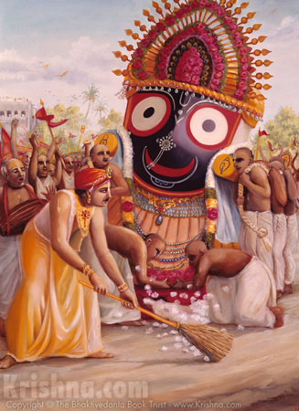

Lord Chaitanya would dance in ecstasy during the Ratha Yatras: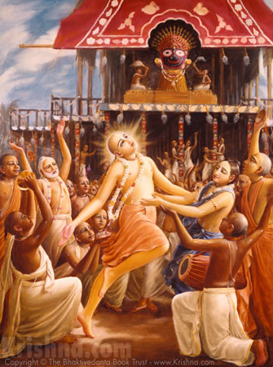

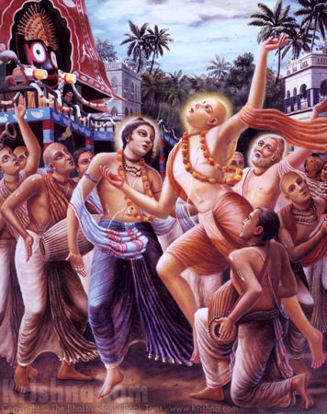
"Everyone was astonished by the dancing of Chaitanya Mahaprabhu, and even Lord Jagannatha became extremely happy to see Him. The car came to a complete standstill and remained immobile while Lord Jagannatha, with unblinking eyes, watched the dancing of Sri Chaitanya Mahaprabhu."
-Chaitanya-charitamrita, Madhya-lila 13.98-99

One day the Lord’s cart would not move:
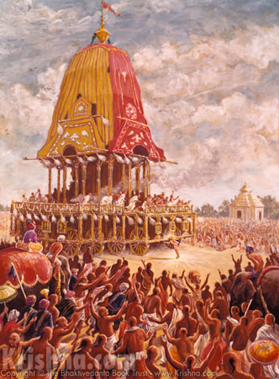

#3
All the workers had tried to pull the rathayatra cart, but it would not move. The king brought wrestlers to try to move it, and when they could do nothing he had elephants brought forward and harnessed to it. Still the cart would not budge. When Lord Chaitanya then approached the rathayatra cart, He began to push it from the back with His head. Only then did the cart begin to move automatically, and from then on it moved along so effortlessly that the devotees did not even need to pull, they simply held the ropes in their hands.
- Summarized from Chaitanya-charitamrita, Madhya-lila 14.47-
Here is another sweet story from Chaitanya Charitamrita in connection with Lord Jagannath:

"One day, when Sri Chaitanya Mahaprabhu went to visit the temple of Lord Jagannatha, the gatekeeper at Simha-dvara [the lion gate outside the Jagannatha temple in Puri] approached Him and offered respectful obeisances. The Lord asked him, 'Where is Krishna, My life and soul? Please show Me Krishna.' Saying this, He caught the doorkeeper's hand. The doorkeeper replied, 'The son of Maharaja Nanda is here; please come along with me, and I shall show You.' Lord Chaitanya said to the doorman, 'You are My friend. Please show Me where the Lord of My heart is.' After the Lord said this, they both went to the place known as Jagamohana, where everyone views Lord Jagannatha. 'Just see!' the doorkeeper said. 'Here is the best of the Personalities of Godhead. From here You may see the Lord to the full satisfaction of Your eyes.' Sri Chaitanya Mahaprabhu stayed behind the huge column called the Garuda-stambha and looked upon Lord Jagannatha, but as He looked He saw that Lord Jagannatha had become Lord Krishna, with His flute to His mouth."
-Chaitanya-caritamrita, Antya-lila, 16.80-85

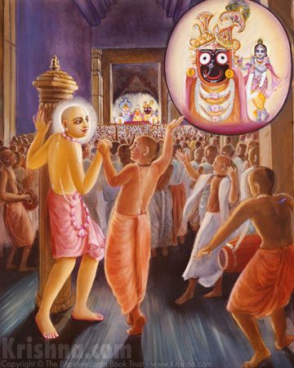

A fiction story about devotee children
Part 3:
Akshay really wanted more crowns and outfits, jewellery for his new deities. He asked his mother if they could go shopping, but she said they didn’t have enough money to spare right now for outfits, but she said she would make some and also teach him how to make necklaces with some pearls that they already had. She said Jagannath would love a necklace made from pearls, because He lives by the ocean, and that’s where pearls come from. It was fun making the necklaces, but Akshay knew that his mom was pretty busy and it would be a while before he got any new outfits.
That week was going to be Akshay’s birthday. He was turning 8! (or 7, if you prefer ;-) wait, hope you read through this before you started reading the story to your kids… ) He was so excited about his party. He had planned a whole treasure hunt for his friends. He and his papa had made the riddles for the clues of the treasure hunt, and the treasure hunt lead to a treasure of sweets tied up inside a clay water pot hanging from a tree. Then his friends were going to smash the pot with a stick, blindfolded. He had spent the whole week painting the pot to look like an ugly demon.
Now he had Jagannath though, he wanted to include them in the party as well. He found a gardenia tree that had lots of gardenias that were too high up to reach. That’s why they were still there of course. The lower gardenias had all been picked. Even though they were really high up, he could smell them from where he was standing. They smelled so sweet, no wonder they are called Gandharaj- king of smells. They would be perfect for Lord Jagannath, Lord of the Universe. He had to beg his mom to figure out a way to get the gardenias, but then she got the ladder all the way from their house and they picked them together and brought them home a little basket. 42 gardenias! They kept them in the fridge so that they would not wilt before the party the next day.
The next day there were lots and lots of preparations to do. Decorations, drinks, snacks, cake, cleaning… his mom kept working nonstop. Grandma even took Baby Shyam to the goshala to get him out of the way. After he helped his mom clean the house, he brought his little altar table into the main room and placed Lord Jagannath on their silk. He decorated the altar with a couple of roses and placed the gardenias in a basket on the floor next to them. When his friends came, they could each offer a gardenia to his Deities!
The party was a great success, even though mommy burnt one of the cakes, after it got icing on top, no one noticed. The best part though is that his Grandma gave him 500 rs to spend on new outfits for his Jagannath! How did she know? That night, after he got ready for bed and put his Deities to sleep, he got to go shopping with Grandma. They even packed up the Deities in Their box and brought them to the shop to try His outfits on!
Akshay found a beautiful outfit that was green with mangoes on it! Then he found a matching crown that was gold with green gems and matching necklaces. That was all he had money for, but he had plans to save up for tiny cups that he could fill up to the brims!
Akshay went to sleep with a smile on his face. This had been the best birthday party ever!

Song related to the Stories

This great song was composed in the 80s by Bhavatarini in Los Angeles. She also made a coloring book and a CD with many more songs. I am trying to get a link where you can buy the whole CD.

Cleaning Gundicha temple
Lord Jagannath and Subhadra
And Lord Balarama
Soon will appear on chariots drawn
To the Gundicha Mandir
Hundreds of water pots, hundreds of men
Await for the signal to begin
To cleanse the temple is Chaitanya’s will
This His devotees wait to fulfil
Cleaning began, chanting all the while
Competing to make the biggest dirt pile
Gathering dirt and dust straw dung
Of course Lord Mahaprabhu won.
Chaitanya praised if one’s work did excell
Chastised when needed, with love as well.
Everything asked for using the Holy Name
The reply would be the same.

Some brought the water
Some swept with brooms
Washing and polishing all the rooms
Some fetched from the lake, some from the well
Sometimes colliding pots broke and fell.
Chaitanya cleansed Jagannath’s sitting place
With His own clothes to wipe every trace.
So bright and clean, it did appear
Like Chaitanya’s mind so pure and clear.

Lord Hari chanting blissfully
Washing the temple in ecstasy
Lord Hari chanting blissfully
Washing with tears of ecstasy
By His example we can tell
One who cleans the temple, cleans the heart as well.
By His example we can tell
This mahamantra cleans the heart so well.

Then they let the water free
Flowing like rivers to the sea
The temple clean now shone brightly
Like the hearts of the pure devotees
Lord Hari began to roar
Krishna’s Holy Names loudly
With the other devotees
Hare Krishna Hare Rama
They did all begin to cry
The sound vibrated in the sky
Dancing like a maddened lion
In this state Gaur Hari
Shook the earth with ecstasy
Shook the earth with ecstasy
Shook the earth with ecstasy
Shook the earth with ecstasy

Bhajans for Parents to learn and sing and listen to.
This song is very very beautiful and glorifies how Lord Chaitanya is the same as Lord Jagannath and Krishna Himself. The melody is on the webpage here: http://kksongs.org/vsongs/jayajayajagannatha.html

(1)
jaya jaya jagannātha sacīra nandan
tribhūvana kore jār caraṇa vandan

(2)
nilācale sańkha-cakra-gadā-padma-dhar
nadīyā nagare daṇḍa-kamaṇḍalu-kar

(3)
keho bole purabete rāvaṇa badhilā
goloker vaibhava lilā prakāśa korilā

(4)
śri-rādhār bhāve ebe gorā avatār
hare kṛṣṇa nām gaura korilā pracār

(5)
vāsudeva ghoṣa bole kori joḍa hāt
jei gaura sei kṛṣṇa sei jagannāth

TRANSLATION
1) All glories, all glories to the dear son of Jagannatha Misra and Saci Devi! All the three worlds offer prayers unto His lotus feet.

2) In Nilacala He holds the conch shell, disc, club, and lotus flower, while in the town of Nadiya He holds a sannyasi staff and water pot.

3) It is said that in olden times, as Lord Ramacandra, He killed the demon Ravana. Then later, as Lord Krsna, He revealed the splendrously opulent pastimes of Goloka.

4) It is He who has come. He has come! Oh, from Vraja He has come to Nadiya. Accepting the mood and luster of Sri Radha, He has come from Vraja to Nadiya. He has come! Now Lord Govinda, the cowherd boy, has come as Lord Gauranga. He has come distributing the Hare Krsna Mahamantra!

5) Vasudeva Ghosa says with folded hands, “He who is Gaura is He who is Krishna is He who is Jagannatha.”

I would like to share with you parents this anecdote I wrote 10 years ago:

jay jagannath!
the wind calls me closer as i stand against the roaring wind, watching the fishermen get ready for a turbulent onset into the ocean. those same fishermen once pulled an unlikely cargo from the depths--a golden body emerged, not realising His surroundings, having already drowned in krishna prema.
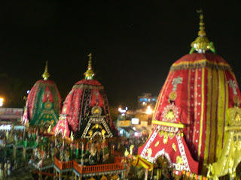
I arrived in puri 2 days after Ratha Yatra, not knowing what to expect, as the main Rathyatra was already over. I came on an adventure, on a journey--literally yatra in bengali and sanskrit. Even though I knew I would not be here for the ulta rath, where Jagannath&co. go back to Their temple, this journey has been worth it.
The day that I arrived, after swimming very briefly in the violent sea, getting drenched in the downpoar, and taking a third bath in the hotel, I ventured to the Gundica mandir for my chance to see the Lords. Although Gundica Mandir also does not like foreigners inside the temple, Jagannath had not yet entered!
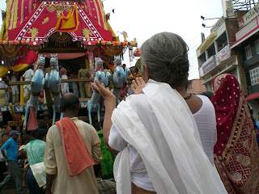
Standing in front of Jagan Nath,
looking at everyone coming to see
He Who has come to see them
at the end of His path.
Why is His name Jagan Nath?
Lord of the Universe, yet hidden
in a fishing town in Orrisa.
His form is ecstasy, drowning in love of Radha.
Krishna outside. Radha inside.
Why did Caitanya come to this village?
Crown jewel of avatars, yet hidden
in a fishing town in Orrisa.
His form is ecstasy, drowning in love of Krishna.
Radha outside. Krishna inside.
The Lord of the Universe
The Crown Jewel of avatars
Embracing the whole world
Swimming in intimate emotions
in a village by the ocean

I finally typed up some of the Advent of Jagannath ballad -You can watch the whole film here: https://www.youtube.com/watch?v=ueWPTgz1cCA
The lyrics below only tell part of the story. The rest of it is acted out in between. I have included them in case you want to learn some of the song yourselves.

The story which we want to show,
Tells of a king who lived long ago.
Thousands of servants to command
He is the lord over all the land
Yet he neglects his kingdom gay,
Pines for his Lord who lives far away.

The Brahman wandered through the land,
Just to fulfil the king’s command
Searching the country far and wide,
Seeking for the lord on every side.
O’er mountains high and pastures green,
Then came upon this village scene.

Vidyapati stayed at their home
No longer did he want to roam
Served by Vishvavasu’s daughter fair,
In course of time he married her.
He passed his days so pleasantly
So far away from his own country.

The two did beg on bended knee,
To go and see the deity.
Vishvasu gave his solemn word
No one but he would serve his lord.
At last he agreed to take him there,
Only to please his daughter fair.

(Different Melody)
My dear husband, do not fear.
There is a way we can trick my father.
Take these mustard seeds with you
And drop them along the forest path.
For every seed, a plant will grow,
The way to Nilamadhava they will show.

Vishvasu bound him hand and knee.
Lalita begged, set my husband free.
Seeing his daughter lamenting so,
Vishvasu let the young man go,
Back to his king and country fair,
Hastened to tell the tidings there.

Then on the top of Nila Hill,
The king did build the lord’s temple
Jewels and pearls did utilize,
Built a golden dome reaching to the skies
Every endeavor did afford
To satisfy his beloved lord
The king did wait year after year
To see his dearest lord appear
Just when all hope was lost it seemed
The lord spoke to him in a dream
My wooden form floats in the sea
Take me and make your deity.

Suggestions for Nature Altar
- I am still working on ideas for making very easy props for the KC stories- I am thinking of some printables but real cloth and wood is so much nicer I also told the story by just showing the kids the painting of the Gundicha Marjan as I am fortunate to own the Krsna Art Book.
- So to tell the fiction story, I made some “handkerchief dolls” with some dried up forgotten limes for the heads, scraps of cloth, and rubber bands. The other dolls I had already.

Here are my props:
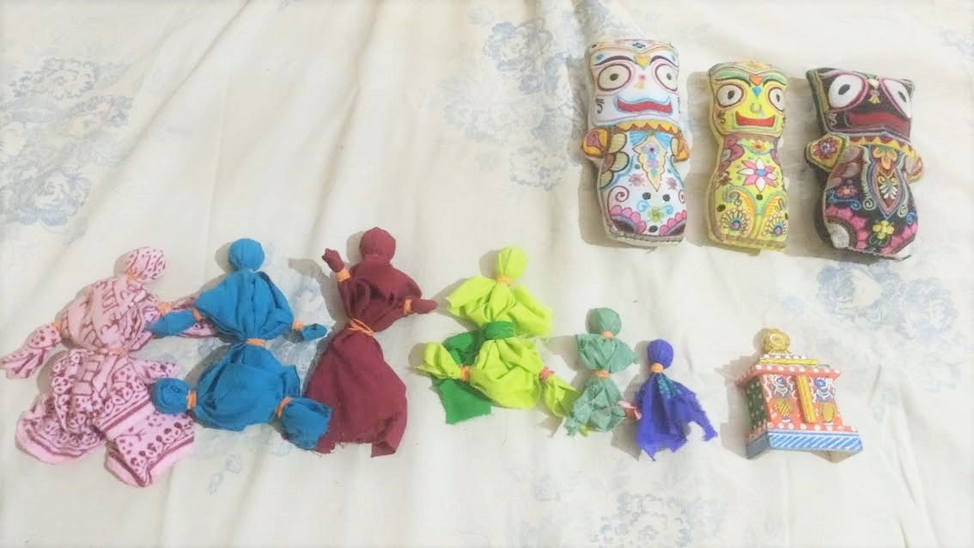
- From left to right, the characters are Pujari Mataji, Grandpa, Mama, Akshay, Sharanam, Baby Shyam, and the present that Akshay got. The big dolls are the deities that Grandpa worships.

An Activity related to the story or festival
Plan a treasure hunt.
Plan a Rath party
Make or repurpose a rath cart.
Our kids and I cleaned the kids’ room from top to bottom, while only speaking and singing the words “Hari! Hari!” It was great fun!

A Field Trip or festival
Although the official Gundicha Marjan day is the day before Ratha Yatra, I hope I can visit the nearby Rajapur temple for some post- Ratha Yatra cleaning.

Recipes for this week
Jagannath Dal and Puris
Reminder: To save cooking time, you want to soak the dal the day before!
There are many kinds of dal. Mung is the most common and favorite in ISKCON, but there is one variety that is really delicious and is often made in Puri with a little sweetness for the pleasure of Lord Jagannath. The variety of dal that is best for this style of preparation is Choler Dal in Bengali, and is sometimes called Bengal Gram Lentils in English. You could also use yellow split pea, which is really quite similar.
Choler dal takes ages to cook, so the day before you want to soak about 1 Cup of it. Please be patient with me as I am writing this recipe from memory without getting a chance to test it out, so please let me know if there are any corrections that need to be made!
I think 1 Cup Bengal Gram Dal is good for a medium sized family.
Soak it overnight. This is a great chance for kids to see how things change overnight- the dal will get bigger and the water might get a little foamy.
Rinse out the water and boil the dal in a pressure cooker if you have one. I am sorry I have not checked how long exactly this takes, or how much water exactly you need! If anyone wants to share what works for them please feel free. You want this dal to be moderately thick and creamy. It can take an hour or two even. Toward the end of the cooking, you can add:
1 tsp turmeric
1 TBs salt (or whatever you think)
3 Tbs gur or brown sugar (or more if you want it a bit sweet)
1 Tbs ghee
When the dal is cooked, you can chaunce it:
In a small pot, heat
2 Tbs Ghee or coconut oil
Fry:
A Bay Leaf
1 tsp black mustard seeds
6 cardamom pods
1 tsp anise seeds (not star anise)
½ tsp asafetida
2 Tbs grated ginger (or less if your kids are really sensitive)
¼ cup dried coconut if you like
After adding the chaunce to the dal, you are done!
If you feel motivated, a really nice accompaniment to this dal that little kids always love is Puris!

Sorry I am not a huge puri maker, but here is a link to a recipe:
http://www.spiceupthecurry.com/poori-recipe/

Other Resources and Links:

Here is a cute little computer puzzle of the gorgeous painting of Gundicha Marjan by Dhriti dd.
1http://www.iskcondesiretree.com/page/games-gundicha-marjan-image-disorder-puzzle
You can learn about and buy beautiful Jagannath Subhadra Baladev dolls here:
http://radhakrishnadollsoflove.com/lrk/jbs/jbs.html

Let me know if you have anything else to add!

